Is malaria control profitable? Return on investment of privately-managed residential fumigations at a large sugarcane processing facility in Southern Mozambique

Joe Brew§*†‡, Kizito Gondo, Elton Dorkin, Menno Pradhan‡, Laia Cirera*†, Elisa Sicuri*†Փ

§ Corresponding Author: joebrew@gmail.com; +34 666 66 80 86
* Barcelona Institute for Global Health: c/ Rosselló, 132, 5è 2a. 08036, Barcelona, Spain, Spain
†Centro de Investigação em Saúde de Manhiça: Vila da Manhiça, Bairro Cambeve, Rua 12, Distrito da Manhiça, CP 1929, Maputo, Mozambique, Mozambique
‡ VU University Amsterdam: De Boelelaan 1105, 1081 HV Amsterdam, Netherlands, Netherlands
Maragra Açucar SA, Subsidiary of Illovo Sugar Ltd: CP 2789, Maputo, Mozambique, Mozambique
University of Amsterdam: REC E, Roetersstraat 11, Amsterdam, Netherlands, Netherlands
Փ Imperial College London: South Kensington Campus, London SW7 2AZ, U.K., UK

American Economic Journal: Applied Economics (priority 0)
Journal of Health Economics (priority 1)
Health Economics (priority 2)
use Gunter Fink Journal of Health Economics as the base structure
- Intro
  - malaria
    - burden med
    - burden (economic +++)
    - avert (IRS, ITN, although no vaccine yet importance of population level stuff, externality)
    - who delivers malaria management
      - govt
      - private
  - Private sector in Mozambique
    - What they do
    - foreigners vs. locals
    - malaria
  - Rationale
    - ROI on malaria preventive health technologies among private sector in Mozambique
  - Put study in methodological context:
    - we do this via maragra using (administrative) data
      - this has already been done (gunther fink, barofsky, etc.) (give lots of details on their studies)
      - The added value of our study is externalities, granularity, etc.…
  - Study background (study area)
    - history, location, size, seasonal workers, etc., hiv, etc.
    - context with south africa, elimination, etc.
  - Study design and descriptive statistics
    - Data description
      - costs, trends, etc. absenteeism rates, IRS coverage
    - Descriptive statistics
      - Absenteeism by IRS time, charts, etc.
    - Intervention description
  - Model / identification strategy
    - externalities
  - Impact on absenteeism
    - Translation to costs
    - ROI
  - Robustness checks
  - Discussion
    - Methodological discussion (why fe individual, not other models, etc.)
    - Mechanisms (density, size, malaria burden) - interpretation
    - generalizability, scenarios
  - Summary and conclusion

Introduction
Malaria accounts for a half million annual deaths worldwide (N. J. White et al. 2014; World Health Organization 2016; Ashley, Pyae Phyo, and Woodrow 2018). Though rapid improvements in technology and funding have lead to important reductions in malaria’s global burden, the scale-up in activities required for eradication (“the worldwide interruption of transmission”) (The Lancet 2011) will mean new partnerships and actors. One promising - albeit atypical - potential stakeholder in global malaria eradication is the private sector, given its omnipresence and potential to benefit directly from the elimination of malaria. But little evidence exists demonstrating how private sector entities can engage with malaria control and benefit at the firm level.
At the societal level, malaria has a large economic impact. By affecting saving, investment (Shretta, Avanceña, and Hatefi 2016), risk perception, productivity, absenteeism (Nonvignon et al. 2016), human capital accumulation (Castel-Branco 2014), mortality, and costs of care (Sachs and Malaney 2002), malaria likely has a negative effect on GDP and growth (McCarthy, Wolf, and Wu 2000; Orem et al. 2012). Because of the relative affordability of most interventions and the enormous societal costs of malaria, most forms of malaria control are cost-effective when a public welfare perspective is assumed, such as when a government provides the financing (M. T. White et al. 2011; Purdy et al. 2013; Howard et al. 2017).
From the perspective of the private sector, however, investing in malaria control is not so clear-cut, since the benefits are often disperse, long-term, and difficult to quantify. Public health interventions targeting malaria - and their corresponding cost-effectiveness evaluations - most often focus on impacts pertaining to public welfare, such as an increase in life years adjusted for disability or quality (Goodman, Coleman, and Mills 1999; Shretta, Avanceña, and Hatefi 2016; Hanson 2004). Though population-level health is certainly of importance to businesses, and improvements in health incidentally improve the economy at all levels (Vecchi, Hellowell, and Gatti 2013), these improvements may be too disperse or long-term to incentivize private sector involvement in health campaigns. In other words, the returns for malaria control are less for the private sector because (i) they capture only part of the benefits and (ii) they do not benefit from the externalities.
Just as the benefits of malaria control to the private sector are more limited than those to the public sector, considerations regarding costs for a firm are also distinct than those for a government. Though many firms in endemic regions engage in malaria control programs, this should not be considered, per se, evidence of its cost-effectiveness (since the extent to which corporate social responsibility plays a role is unknown).
100% of the Mozambican population are at risk of malaria, living in what the WHO classifies as a “high transmission” area (Moonasar et al. 2016). Annually, Mozambique has more than 8 million clinical malaria cases (an annual incidence of approximately 300 per 1,000 residents), with an estimated 14,000 deaths. Malaria accounts for 29% of all deaths, and 42% of deaths among those under five years of age (INE 2011). Since 2013, Mozambique has seen a gradual increase in the incidence of malaria (Moonasar et al. 2016). 100% of the malaria in Mozambique is of the Plasmodium falciparum species, with Anopheles funestus, gambiae, and arabiensis as the primary mosquito vectors of the disease (WHO 2015).
A significant sector of the economy in Mozambique is dominated by large-scale foreign direct investment projects (Robbins and Perkins 2012; Castel-Branco 2014), and the role of the private sector in health generally, and malaria specifically, is unequivocally important. Large agriculture and extractive industry firms take up wide swaths of land and employ hundreds of thousands (German, Schoneveld, and Mwangi 2013). The Mozambican state has encouraged large-scale entreprise with the aim of general economic development (Buur, Tembe, and Baloi 2012). And where large firms exist, they often take on social roles such as housing and health care (Buur, Tembe, and Baloi 2012; Winkler 2013). At times, this role is necessary from a purely practical standpoint; in other cases, it is employed under the auspices of “corporate social responsibility” (Azemar and Desbordes 2009; Curtis et al. 2003). Regardless of the language used, it is clear that private industry plays an important role in public health in Mozambique (Robbins and Perkins 2012; Castel-Branco 2014).
To address the question of the profitability of malaria control activities from the standpoint of a private firm, we analyze data during a 4 year period from a private sugar facility in Southern Mozambique. We use absenteeism as our outcome variable, assuming that it is directly correlated with the productivity losses associated with malaria infection. We assess the effect of indoor residual spraying (IRS) on absenteeism, and demonstrate that the firm’s engagement in malaria control not only improved worker health, but also generated a positive return on investment from a pure accounting perspective.
The structure of the paper is as follows. We provide an overview of the sugar company under study, and the epidemiology of malaria in the nearby area, as well as in Mozambique as a whole. We then give an overview of the data collected, and outline the theoretical and methodological assumptions and tools that underlie our analysis. We assess the effect of time since IRS on worker absenteeism, controlling for malaria seasonality, and segregating models for four different worker types. In the results, we show that IRS spraying is associated with a significant reduction in worker absenteeism among permanent and fieldworkers, and has little to no effect on temporary and indoor workers. We find that, in addition to reducing absence, the IRS program has a cost savings effect. Our discussion covers potential implications from this study in terms of policy and investment, as well as the paper’s limitations.

Background literature
The evidence of malaria’s negative effects on both health and wealth, at both the individual (Cole and Neumayer 2006) and collective (McCarthy, Wolf, and Wu 2000) levels, as well as in both the short (Asenso-Okyere and Dzator 1997; Ajani and Ashagidigbi 2010) and long (Hong 2011; Sachs and Malaney 2002) terms, are amply described in the public health and economics literature (Phillips 1998). That said, very little exists in the literature examining the costs and benefits of malaria control from a private ledger perspective (ie, the point of view a business investor). Unlike a government or individual, a private firm investing in malaria control may be most interested not in its long-term macroeconomic effects, nor its short-term personal health effects, but rather on the impact on productivity (and the extent to which that productivity benefits accrue to the firm), absenteeism, and the opportunity costs of expenditures in malaria control. In other words, though the large magnitude of malaria control’s benefits are well known, the portion of those benefits accrued by a private firm investing in malaria control is unknown.
In general, large firms operating in malaria endemic regions consider malaria to be an important enough issue to merit at least some investment (Pluess et al. 2009). Several studies examine the effect of foreign firms engaging in large-scale malaria control campaigns (Han 2015; Kaula, Buyungo, and Opigo 2017). AngloGold-Ashanti, in partnership with local and national government in Ghana, invested in a well-rounded malaria control program in 2005, and saw worker absenteeism fall by 50% in 13 months (Ccm 2016). Lafarge’s simultaneous investment in a comprehensive malaria control program in Benin was associated with an average 41% reduction in absenteeism among workers over the course of 4 years (Ccm 2016; Egedeye, Drozer, and Leiser 2011). Zambia Sugar Plc, Zambia’s largest sugar processing facility, saw annual malaria cases at its company clinic fall from nearly 3,000 in 2001 to less than 500 by 2005, following investment in a malaria control program. Marathon Oil’s investment of 15 million US in vector control, education, net distribution and malaria treatment on Bioko Island in Equatorial Guinea lead to an estimated 95% reduction in the number of parasite-infected mosquitoes and 50% reduction in malaria incidence among young children (Asquino 2016; Overgaard et al. 2012). A PATH study in Zambia found a return on investment of 28% among three companies investing in employer-based malaria control (Mouzin and Al. 2011).
Though certainly suggestive of high returns on malaria control investments, these studies generally consider population health as the outcome measure of interest, rather than worker absenteeism or productivity. Similarly, they often neglect to differentiate between those clinical costs which are absorbed by the local health system versus those which are absorbed by the firm itself. When absenteeism itself is considered, effects of malaria control have generally been found to be high, but causation is difficult to establish, given that the previous studies rely on aggregate data.
Two studies utilize worker-level data to estimate the effect of malaria control on productivity. A World Bank analysis of Nigerian sugarcane cutters found that the simple availability of testing and treatment increased productivity by 10% in the weeks following the provision of services, the conclusion being that both the treatment and the test result were effective in increasing productivity, the latter simply increasing the information available which could influence personal labor allocation decisions (Dillon, Friedman, and Serneels 2014). A randomized controlled trial (RCT) in Zambia showed an even greater effect from investments in preventing malaria: farmers given bed nets saw fewer days lost to illness (both directly and due to caretaking responsibilities for ill family members), translating to an increase of approximately 15% in crop yield(Fink and Masiye 2015). Though compelling, the Nigerian program only dealt with medical services (diagnostics and medication), rather than preventive interventions, and the Zambian RCT examined individual farmers, as opposed to a large firm.
In the literature, making the “investment case” for malaria control or elimination generally implies that the investor is the public sector, and takes into account those costs and benefits which are applicable from a public welfare point of view (Shretta et al. 2017). For example, an economic analysis by the Corporate Alliance on Malaria in Africa on the Bioko Island Malaria Control Program found a 4:1 cost-benefit ratio, but the perspective in this case was considered to be the “community” (Egedeye, Drozer, and Leiser 2011). Though appropriate in most cases to consider benefits accrued to the community (the government or institutions interested in public welfare primarily being the primary malaria control agents in most locations), the findings of these studies are rarely applicable to the private sector, and even less so at granular levels (such as an individual firm). In the case of a private firm not interested in “corporate social responsibility”, it is not clear whether investing in malaria control would be profitable or not. This lack of clarity not only discourages investment, but also makes it difficult for governments to pinpoint the correct of amount of subsidy (if applicable) to encourage private sector scale-up in malaria control (Alonso, Munguambe, and Sicuri 2017).
The literature on the effect of sugarcane cultivation on malaria risk is mixed. While some studies have found that the prevalence of malaria vectors in sugarcane areas to be similar to that of uncultivated areas (and less than in areas dedicated to other forms of more water-intensive agriculture, such as rice) (Ijumba, Mosha, and Lindsay 2002), other studies have found significant increases in factors associated with malaria transmission at large-scale sugarcane facilities relative to traditional, small-scale farming and non-irrigated farming (Jaleta et al. 2013). Regardless of the effect the presence of a sugarcane farm per se on local malaria epidemiology, the time spent outdoors by sugarcane workers, the fact that many workers are migrants, and their sometimes precarious housing situations, suggest that sugarcane farmers are likely at increased risk of malaria infection (O’Laughlin 2016). This is important, given that even among occupations with far less inherent exposure to mosquitoes (such as health professionals), malaria is one of the primary causes of work absenteeism in malaria-endemic countries (Burton et al. 1999). There is also some concern regarding the effect of large-scale insecticide use - common at essentially all Sub-Saharan African sugarcane farms - on insecticide resistance among mosquitoes in the area. A study in Belize found that mosquito populations on the edge of sugarcane fields had higher tolerance to insecticide than similar populations in the core of fields or outside of the periphery (Dusfour et al. 2009). Sugarcane areas may offer the standing water necessary for mosquito breeding, but also perhaps attract mosquitoes which would otherwise be elsewhere, due to compounds in sugarcane pollen (Wondwosen et al. 2018).
This study does not endeavor to expand the current body of knowledge regarding malaria’s ill effects on individuals and societies; rather, it aims to provide empirical evidence pertaining to a facet of malaria economics with very little in the literature: malaria control from a private-sector investment perspective. Our study adds to the existing literature by showing the effect of specific malaria control interventions on worker absenteeism, and translating that effect into a return on investment. Unlike previous studies on the effectiveness of malaria control interventions, our’s focuses solely on one firm carrying out one intervention, takes advantage of individual-level data, and analyzes results from a ledger perspective.

Study area
Sugar has been systematically cultivated in Mozambique since the late 1800s. The Incomati Estates company, a small sugarcane processing facility started by a Scotsman on the banks of the Incomati River in 1913, was the first firm to export sugar from Mozambique. Following its purchase by international investors in the 1950s, it (along with the rest of the industry) expanded significantly, exporting to both Europe and the United States. In the late 1960s, a Portuguese family opened the Maragra Açúcar company, while a group of foreign investors started the nearby Marracuene Agrícola Açucareira mill. By the early 1970s, sugar grew to account for greater than 10% of Mozambique’s national exports. Nationalized following independence in 1977, the industry’s production levels fell from 320,000 annual tons to fewer than 15,000 by 1992. After the end of the civil war, foreign investment revived the sugar industry, and by 2011 production had surpassed its 1972 peak.
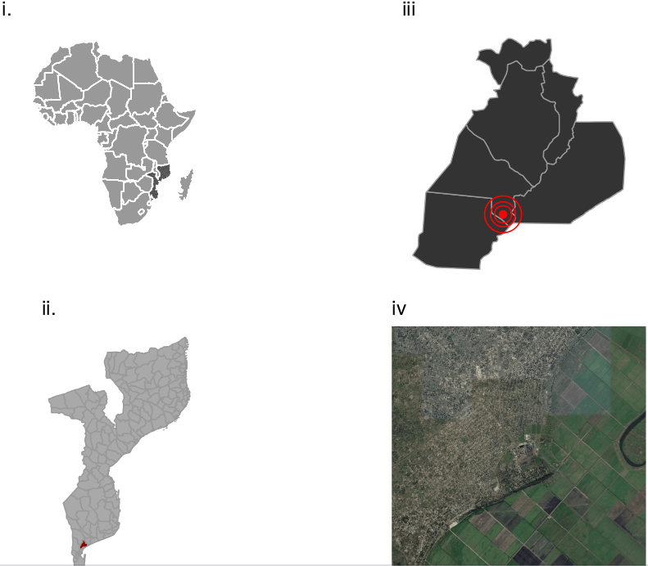
(i) Mozambique in Africa, (ii) Districts of Mozambique with Manhiça highlighted in red, (iii) District of Manhiça with Maragra highlighted in red, (iv) Maragra SA with surrounding fields and village
The mill of the Maragra Açucar SA (a subsidiary of the Illovo sugar company, henceforth referred to as “Maragra”) was nationalized in the 1970s (like all other Mozambican mills), went through a period of low production, and then fell completely out of use by 1984. It re-opened in private hands in 1992, and was renovated by a group of international investors in 1998. Today, Maragra accounts for roughly one quarter of Mozambique’s overall sugar production (second only to the nearby Xinavane mill run by the Hulett Sugar Tongaat company) (Sutton, J., Mapa empresarial de moçambique). With a favorably close location to the port of Maputo, ample land (approximately 90 square kilometers of plantation, and 5 squared kilometers of factory grounds), approximately 5,000 employees (of which three quarters are seasonal), and a mill with the capacity to process not only all the sugarcane grown on Maragra’s land, but also the cane of the many nearby smallholders (O’Laughlin 2016), Maragra has so far been able to weather the 2016 Mozambican crisis and concurrent collapse in global sugar prices.
Maragra (figure 1, panel iii) is located in the district of Manhiça (figure 1, panel ii), a semi-rural area in the south of Mozambique (figure 1, panel i). 80 kilometers north of the Mozambican capital of Maputo, the district is low-lying, consisting largely of savannah and wetlands along the Incomati River. Most of the areas 160,000 residents (Sacoor et al. 2013) work as subsistence farmers. Migration from the area to South Africa for the purpose of employment in the profitable construction industry is common, especially among men (Nhacolo et al. 2006), as is migration to the area (from other parts of Mozambique) for seasonal work on the sugarcane plantations at Maragra and the slightly larger facility in Xinavane (at the district’s border with Magude) (O’Laughlin 2016).
Poverty is rife in southern Mozambique, and its associated illnesses take their toll on the population. The community prevalence of HIV/AIDS is as high as 40% (González et al. 2012)); even in a more recent study suggesting a much lower prevalence of 22%, the risk of infection is still twice that of nearby areas (Mocumbi et al. 2017). Recent years have seen a three-fold increase in tuberculosis (García-Basteiro et al. 2017). Malaria, which has the greatest mortality burden due to the fact that the young are especially vulnerable to its effects, is perennial, though worse during the rainy season (December - March) (Saúte et al. 2003). Adult malaria is essentially universal, albeit much of it asymptomatic (Mayor et al. 2007). In regards to worker health, malaria is Maragra’s primary concern, being so important as to justify the existence of both an on-site testing laboratory and clinic, as well as a malaria control department.
Maragra workers are mostly seasonal, working for the firm approximately half of the year during harvest time, and cultivating crops, working in construction, or going unemployed (or working elsewhere) during the other half. Though many workers live “on-site” (ie, within the delineated property of the firm itself), a sizeable minority resides in the environs (figure 1, panel iv). Maragra provides indoor residual spraying (IRS) using ACT (alpha-cypermethrin) and DDT (Dichlorodiphenyltrichloroethane) depending on stocks (a preference apparently exists for the former, but it is not always available). IRS activities, managed by Maragra’s Malaria Control program, are ongoing throughout the year (Figure 1, panel i). Nearly all on-site houses are sprayed, though the time between fumigations is irregular (Figure 2, panel ii). Off-site houses may also receive IRS (managed and carried out by the National Malaria Control Program), but the status and timing of these fumigations is not known at the individual level.
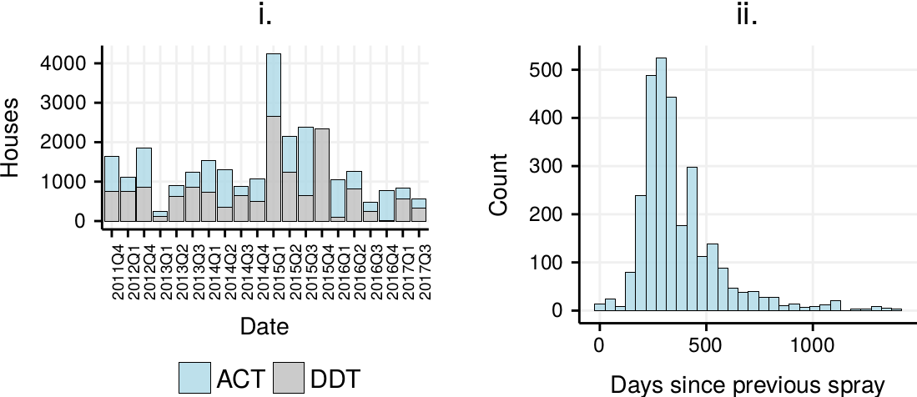
i. Fumigation activities carried out by Maragra Malaria Control during study period, ii. Distribution of average time between sprayings of households

Methods

Data
In collaboration with the sugar processing facility, we collected data for the period from January 2010 through December 2016. Data came from four sources: (i) the Human Resources’ roster of worker details and absences, (ii) the facility’s on-site clinic’s medical and laboratory records, (iii) the facility’s on-site malaria control program’s records pertaining to the dates, chemicals, and location of IRS activities, and (iv) interviews with company employees pertaining to costs, data limitations, etc. Digitization and collection of data took place during the period from March 2016 through May 2017. Supplementary data pertaining to worker characteristics was obtained from through the Centro de Investigação em Saude de Manhiça’s (CISM) demographic census, which covered workers from the district, but not those who migrated from other parts of the country (Nhacolo et al. 2006).
Data pertaining to district-wide malaria incidence was obtained from Mozambique’s Boletim Epidemiológico Semanal (BES), which is the system by which the National Malaria Control Program monitors incidence at the district level throughout the entire country, and reports the number of confirmed weekly malaria cases at government health facilities. Using these case numbers, combined with population estimates from the National Statistical Institute (INE), we estimate each day’s annualized weekly malaria incidence rate (cases per 1000 population at risk), interpolated from the weekly figures. We retrieved weather data for all Mozambican stations from NOAA. We estimated the meteorological conditions at the centroid of Manhiça using a simple interpolation method whereby the district’s weather conditions were estimated to be a function of all Mozambican weather stations’ reported conditions, inversely weighted by kilometers from district centroid.
Maragra regularly employs IRS at on-site worker households in order to reduce those workers’ (and their families’) risk of malaria infection. IRS works by killing the malaria vector (mosquito), thereby preventing infection of the household occupants. When administered correctly, IRS is a low-risk intervention to its recipients, and is assumed not to affect absenteeism in the short-term (to the extent that it may cause negative side-effects, these are generally long-term). It is preventive only, and does not cure current malaria infection, nor does it affect the parasite load of mosquitoes. Workers living off-site (our control group) also may have received IRS at some point during the study period (from government programs). Even though we do not have reliable person-level data on IRS carried out by the government, off-site workers are a suitable control in the sense that they represent “business as usual” (ie, what would happen if the company carried out no IRS and relied solely on public interventions). Using company HR and clinical records, we were able to identify absences and episodes of clinical malaria among all workers, as well as identify the time since the most recent IRS episode before the onset of absence or illness.
Worker characteristics, illness and absenteeism data, along with IRS activity data, were systematically stored, collected, and used at the individual level by Maragra, and therefore of generally high quality. Because cost data was less systematically collected by Maragra, and because many costs could not be precisely quantified due to the abundance of in-kind and cross-departmental expenditures, we had to rely on rough estimations based on a mix of interviews, reciepts, and interpolations. Since our program cost data is not as reliable as our worker characteristic and outcome data, we were conservative in our estimates, and generally tried to err on the side of program activities and materials costing more than what was reported, when doubt was aired. Cost data consisted of three types: (i) wages of malaria control employees, (ii) transportation and vehicle costs for IRS teams, and (iii) acquisition costs of purchasing IRS chemicals for fumigation (ACT and DDT), the latter two being combined into malaria control “programme” costs.

Conceptual framework and identification strategy
We sought to understand the effect of IRS on individual workers’ likelihood of absence from work as well as their likelihood of clinical malaria. To estimate this effect, we estimated separate models for absence and illness. We employed linear mixed effects models (Minalu et al. 2011; Liu et al. 2010) (with individual worker fixed effects, and random effects for other covariates) so as to explicitly adjust for confounders (Bell and Jones 2014). We divide into 4 different models for different worker types, so as to account for the potential time-varying effects of worker type on risk of malaria.

Externalities
The administration of insecticide at a worker’s residence (indoor residual spraying or IRS) likely protects that worker from malaria infection by killing the vectors (mosquitoes) that land on the building’s walls. However, it is also highly likely that the protective effective of IRS “spills over” to others who live nearby. This positive spillover effect would theoretically go through two channels: (i) via a reduction of mosquitoes in the vicinity and (ii) via a reduction of the malaria parasite in the blood of humans in the vicinity (ie, the parasite “reservoir”). This document describes our method for assessing the existence and magnitude of positive spillover of IRS in the Maragra workers’ data. We devise a time-specific household “protection” score based on the theoretical effectiveness of IRS, and then use that protection score to develop a time-place specific “herd protection” score based on a weighted average of nearby household protection scores.
We consider a house’s “herd” protection level (ie, the protection conferred to the house through externality) to be the average of the other houses’ non-herd protection levels, weighted by the distance to the house in question. The below is an illustration of a house (the red x) and the neighboring houses (circles). The “weight” of each house is indicated by the circle size, and the protection level of the house is indicated by the shading of the circle.
However, this consideration misses one important dimension: density. The below house’s weighted average protection score is identical to that of the above house. In other words, at the time in question, at both locations, the percentage of houses with IRS coverage is the same, and the (weighted) average time since IRS is the same. However, the below house is likely much more protected than the above, given the absolute number of nearby IRS-protected houses.
Our approach is this: rather than using a weighted average of each household’s individual protection score, we instead use a weighted sum. A particular household’s herd protection score at any given time is the sum of all households’ individual protection scores at that time multiplied by those households’ distance weights.
The summation of (a) the IRS level of other houses at a certain time, (b) weighted by the distance of those houses to the house in question, (c) limited to only the 1 km radius multiplied yields a “herd protection score”.
This score is conceptually similar to Cohen and Dupas’ quantification of the positive externalities of ITN (bednet) use in Kenya (Cohen and Dupas 2010) in that it attempts to estimate the protection conferred to “non-users” by users and uses a “weighted sum” (as opposed to average). Our approach differs in that the time dimension for IRS is much more important than ITN (ie, IRS is not a binary but rather a waning function, as described previously), requiring us to create herd scores for every day.
Our approach can be justified in that previous studies have found strong positive health externalities in malaria interventions related to ITN coverage (Alaii et al. 2003). No studies exist on positive externalities for IRS coverage, but to the extent that the mechanisms for the reduction in infection are similar (reduction in the natural reservoir of the disease, reduction in the number of vectors, etc.), it is reasonable to assume similar effects. Additionally, we are using weighted distance for our score calculation (rather than simply defining a radius threshold) because of previous studies’ findings that there is a linear decline in protection conferred to others with greater distance from an intervention (Binka et al. 2007).
Figure x shows a smooth interpolated surface of herd protection, averaged for the entire study period.
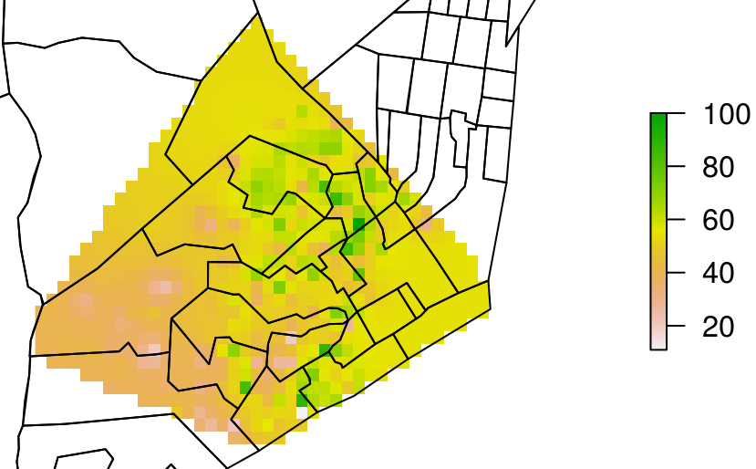
Kernel density surface of average all-time herd protection score for Maragra worker neighborhoods (relative to highest protection)
Some more details will eventually go here.

Econometric model
Our model specification is as follows

is the rate of absence. is the binary “season” variable, imputed from overall district clinical incidence. Our intervention is whether the residence of the worker in question was treated in the last year, and, if so, the time since treatment, represented, respectively, by and . represents the distance-weighted herd protection score. represents the time invariant worker fixed effects, and represents the fixed effect of the particular malaria season. is the error term.
We define the malaria season as any time during which the clinical incidence of malaria in the district of Manhiça was at or greater than the median clinical incidence of malaria for the entire study period. These weeks are flagged as red in Figure 1, Panel A. By using clinical incidence of the area of residence of the workers (as opposed to more typical proxies for malaria risk, such as only rainy vs. non rainy season), our seasonality estimate is a closer approximation of true malaria risk, incorporating lagged effects such as the incubation period of the parasite, as well as any inherent non-linear effects of weather. In addition, we adjust for daily precipitation; though its lagged effect on malaria incidence is likely captured by the seasonality term, we include rainfall since it’s immediate effect (through its impact on transportation and working conditions) may also affect absenteeism.
Our formula for return on investment can be described in a straightforward fashion…
…where is the return on investment, is the malaria control program’s total operating cost, refers to costs at the per-worker level, refers to savings through avoided absences, and $ c $ refers to savings through avoided clinical encounters. We define the malaria control program as “profitable” from an investment standpoint if ROI is greater than 100%, ie if the savings associated with the estimated effect of IRS is greater than the costs of the program’s administration.

Reproducibility and ethical approval
All data processing and analysis were carried out in R (R Core Team, R: A language and environment for statistical computing) and all analysis code is freely available online (Brew 2017). Ethical approval for this project was obtained from the Institutional Ethics Review Board for Health at the CISM (CIBS-CISM) prior to data collection.

Results

Descriptive statistics
We collected absenteeism and demographic data data on 3362 workers from 2012 through 2016. Workers were approximately 60% male, and more than 80% fieldworkers (predominantly cane-cutters). Most were in their 20s and 30s and employed on temporary contracts. Table 1 shows overall worker details divided by “Treatment” versus “Control” status. “Treatment” is considered the time beginning at IRS administration and ending six months later; “Control” is considered time observed either prior to IRS administration (and greater than 6 months after previous IRS administration) or among workers who never received IRS. Because of the temporal nature of these categories, many workers belong to both treatment and control groups, albeit at different times.
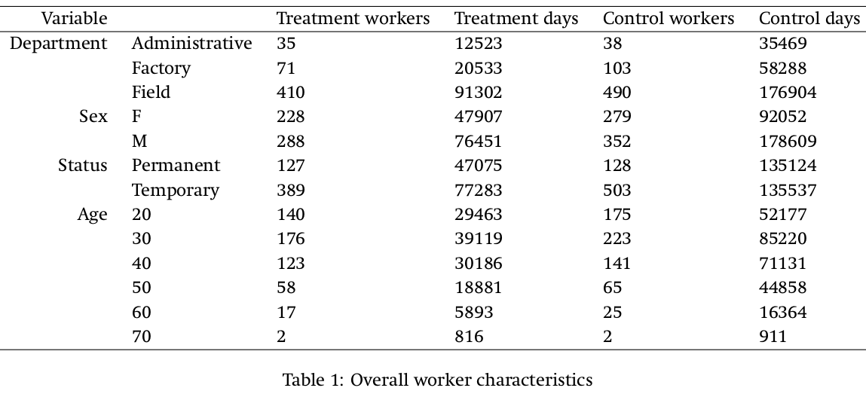
Temporary workers tended to be younger and male; female temporary workers being on average 5-10 years older than their male counterparts. Permanent workers had a bi-modal age distribution, the older peak explained by the greater density of males in administrative roles. Females accounted for 43% of temporary workers but only 16% of permanent workers (figure x).
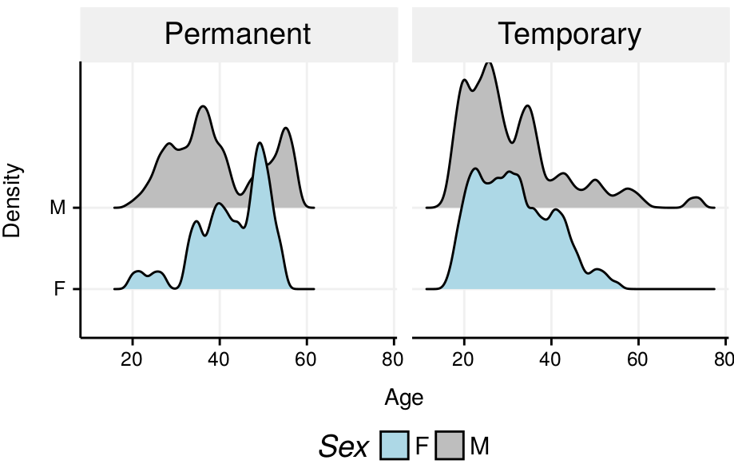
Age distribution by sex and worker status
During the study period, weather followed typical seasonal trends for the area, albeit slightly drier than previous periods.
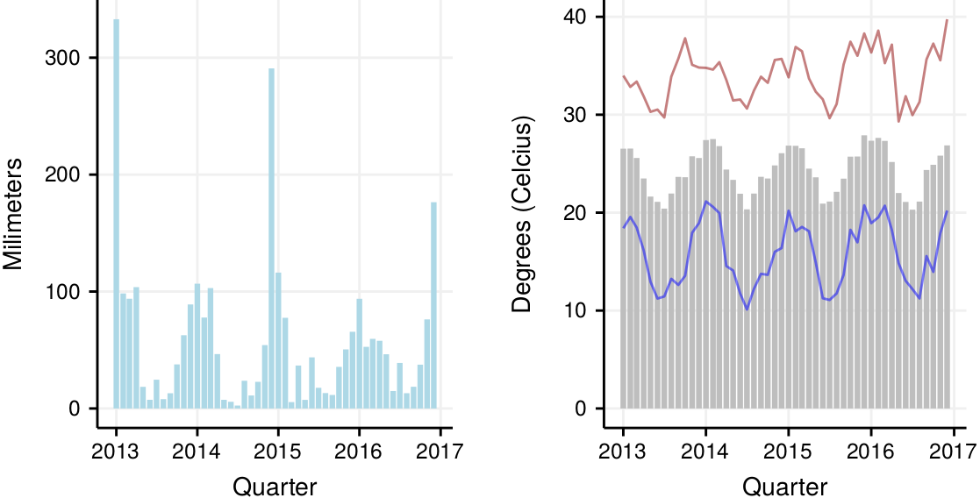
i. Monthly total precipitation in the Maniça district; ii. Average monthly temperature (bars) during the study period, as well as monthly maximum (red) and minimum (blue) temperatures
In Southern Mozambique, malaria peaks during the summer months (December through March) most years (Figure 5, panel A), and worker absenteeism at Maragra rates track malaria incidence closely, following the same seasonal patterns (figure 4, panel B). Both all-cause absenteeism and sick absenteeism have declined in recent years at Maragra (figure 5, panel C), with the latter declining at a faster rate than the former. The fact that the rate of confirmed cases at the company clinic is largely non-seasonal (figure 5, panels E and F) suggests that a significant portion of workers either seek care for malaria elsewhere (for example, government health posts, of which several are nearby and in some many cases closer to workers’ residence than the company clinic) or do not seek care during malaria infection. Accordingly, we focus our analysis on all-cause absenteeism rather than sickness absenteeism or malaria diagnostics, with the assumption that much of illness is captured by absenteeism but not by the clinical data.
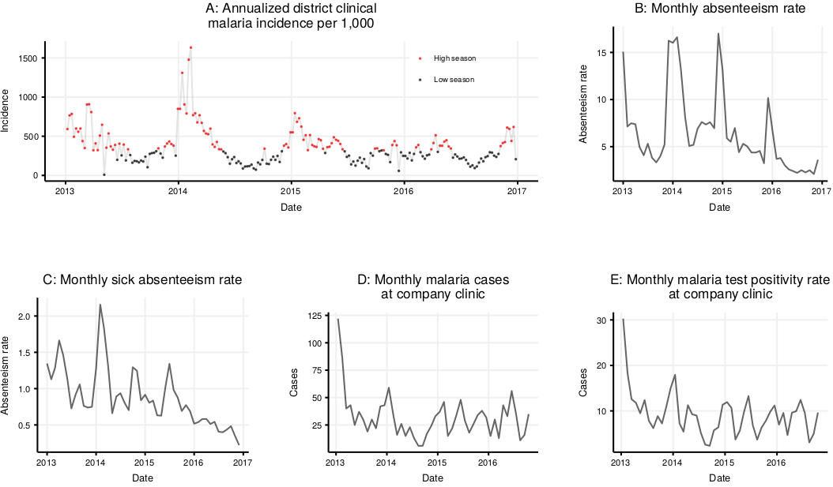
Clinical malaria (district of Manhiça), all-cause absenteeism among Maragra workers, sick absenteeism among Maragra workers, positive cases at company clinic, and test positivity rate at company clinic
Fumigations: During the period from January 1st, 2013 through December 31st, 2016, the Maragra Malaria Control Unit carried out 11,007 episodes of fumigation of residential “agregados” (household combinations), for a total of 13,260 building-fumigation combinations. The total number of unique agregados sprayed during this period was 3,998. Among the 692 workers for whom we have reliable absenteeism and residential data, 562 had their homes fumigated at least once (the majority of workers live off of the facility).
Absences: We observed 1,759,100 unique worker-days among the 692 workers. The all-period average absenteeism rate was 5.56%, though this rate varied widely as a function of worker department, sex, residence, and season (table 2).
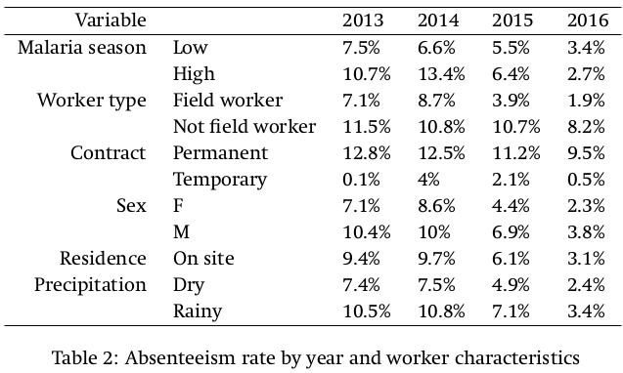
Precipitation: Of the 1454 days observed, 940 had no rainfall at all (ie, approximately two-thirds). On days for which there was any rainfall at all, the average amount was approximately 2.99 centimeters. Rain was most common in December and January (average of 5-5.5 cm daily) and least common in August and September (average of 0.5 cm daily). Days with any rainfall saw more absenteeism than days with no rainfall (Figure 6, panel A) and among days with any rainfall, more precipitation was associated with greater absenteeism (Figure 6, panel B) (correlation coefficient of 0.25).
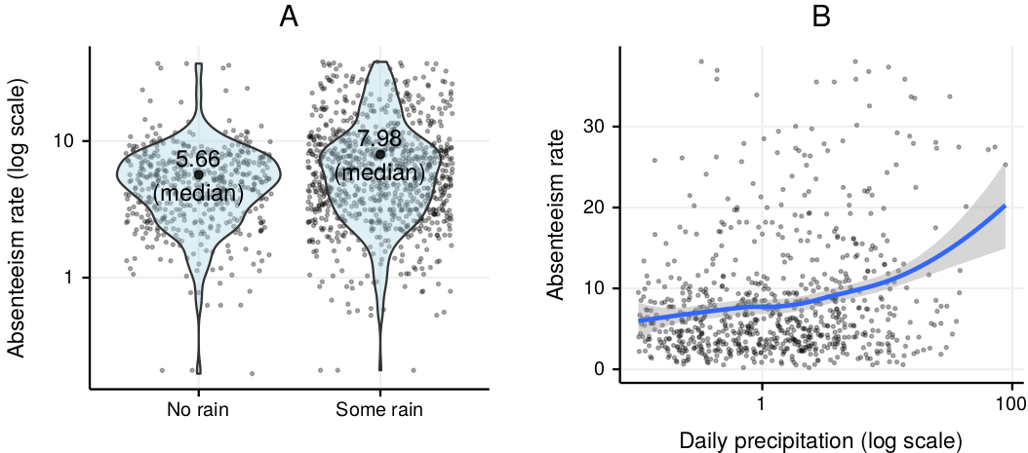
Rainfall and absenteeism: association of any rainfall with absenteeism rate (left) and association of rainfall amount and absenteeism (right)
The extent to which rainfall’s effect on absenteeism is confounded by its effect on malaria is discussed in the model results section.
Costs of program: The malaria control program at Maragra has an annual operating budget of approximately $112,000, which includes the purchase of insecticide, the wages of IRS sprayers and drivers, transportation, record-keeping, and general administrative costs. Assuming linearity in costs, the program spends approximately $19 per building sprayed. With each agregado containing an average of 2.2 workers. Much of the benefit of IRS goes to non-worker residents of sprayed agregados (who constitute a majority), but this benefit is purposefully ignored for this analysis.
Cost of malaria: Given the likelihood that clinical data does not fully capture all malaria cases (and most likely captures only a small fraction of actual infections, given the high rates of acumulated adult immunity [Mayor2007]), we do not quantify the costs of malaria infection to the company. Rather, we first estimate the reduction in absenteeism attributible to IRS, and then quantify the savings associated with prevented absences. Additionally, we calculate the clinical savings of IRS by first estimating the share of absences which are associated with an episode of clinical malaria, and then applying the clinical cost per case to the equivalent share of prevented absences. We intentionally ignore the savings accrued by the public health system, as well as the likely utility gains in secondary realms such as school absenteeism, producitivity, etc.

Analysis

Effect of IRS on absenteeism
Immediately following IRS, a worker’s likelihood of absence drops significantly (appendix figure, panel A). As one would expect if the mechanism by which IRS reduces absence is through reduced malaria infection, the effect of IRS during the low transmission season is significant, but far less substantial in effect size (appendix figure, panel B).
In order to assess the effect of IRS on absenteeism, we created 4 worker fixed effects models for the 4 principal worker types (permanent field worker, temporary field worker, permanent non-field worker, temporary non-field worker) for both outcoms (all cause absenteeism vs. sickness absenteeism). The reason for segregating models rather than incorporating worker type as a fixed effect was that it seemed plausible that the effect of the treatment (IRS) on the outcome would be different (and vary differently over time) depending on these worker types. For instance, it is reasonable to assume that IRS’ effect would be differential for a temporary worker (who likely lives in the fumigated house less than 100% of the year) than for a permanent worker.
Given that IRS is carried out on a continuous rolling basis, we used relative worker time (as opposed to calendar) as the time component of our model - that is, each workers’ days until and since IRS were standardized so that day 0 (date of fumigation) was the interruption point. This has the advantage of incorporating into the model a variety of potential time-varying confounders in a quasi-randomized fashion, thereby making it unecessary to adjust for them specifically. Our model took into account workers’ residential location (on or off site) - even though off site workers by definition could not be administered IRS by Maragra - so as to capture other seasonal effects from those workers.
The herd protection score, unit-less by nature given that it’s a summation of binary protection statuses weighted by inverse-transformed distances, took the following distribution in our data:
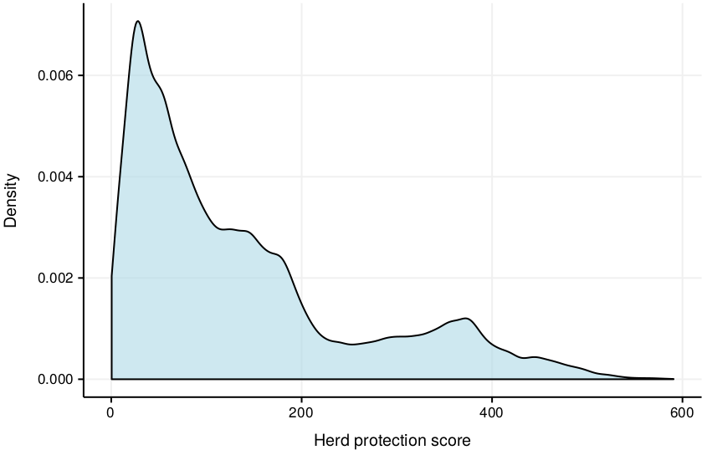
Distribution of herd protection score in panel data
The model results for all cause absenteeism (table 4) suggest a significant decrease in absenteeism following the administration of IRS. The effect is ambivalent among temporary workers, whereas among permanent workers the administration of IRS decreases absenteeism by xxx. These effects are consistent with IRS decreasing absence through the medium of malaria, since (a) the effect is not as strong in the first month (potentially during the parasite incubation phase), the effect is stronger on field workers (who are more socioeconomically the demographic at greater risk of malaria than their administrative counterparts), and the effect is ambivalent among temporary workers (since the protective effect of IRS is only a function of the amount of time that the worker spends in the fumigated house).
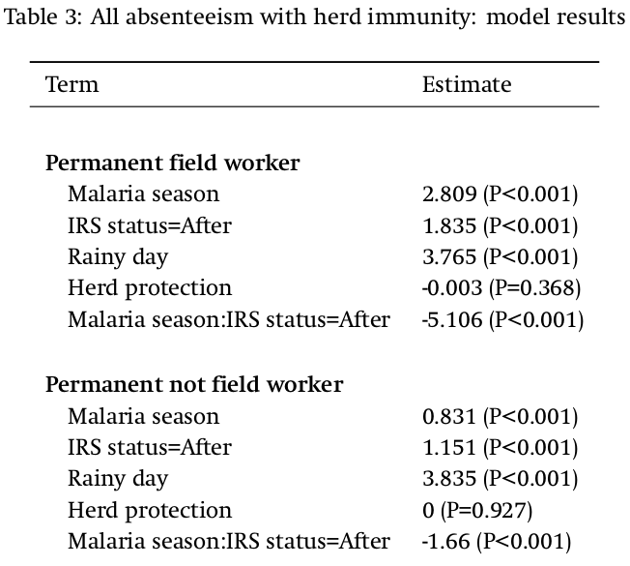
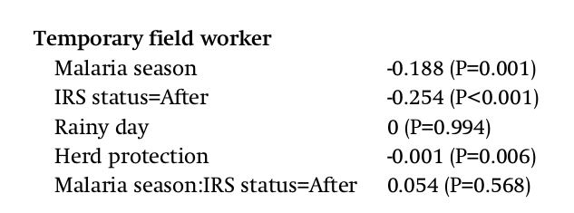
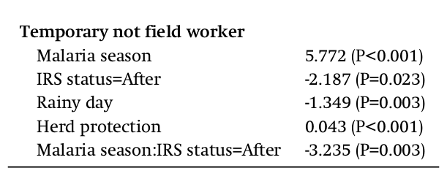

What would happen without IRS?
The below chart shows the modeled average absenteeism rate during malaria season for permanent workers, by group type.
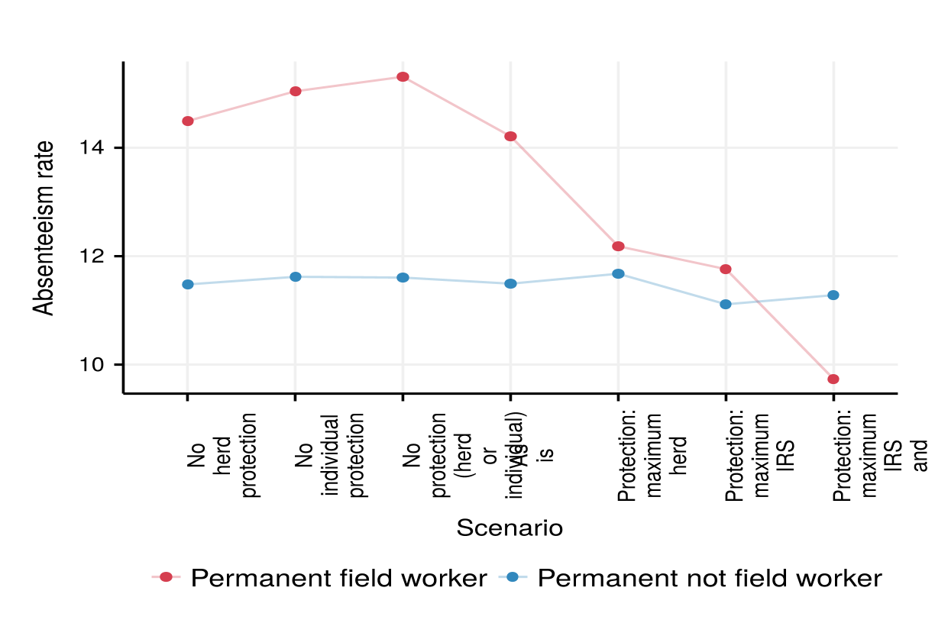

Translating absences to costs
xxx

Return on investment

Savings
- In percentage point terms, reduction from 13% to 8%.
- 5 annually prevented absences per worker.
- 8,000 workers: 40,000 prevented absences, wage of 3 USD
- TOTAL: 120,000 USD in productivity-only savings.
Costs
- 8 IRS workers, 1500 USD yearly = 12,000 USD
- ACT + DDT: 50,000 USD
- Facilities, vehicles, gas: 50,000 USD
- TOTAL: 112,000 USD in IRS-only costs
7% ROI (ignoring clinical costs)

Robustness and generalizability
Two principal concerns call into question the results of our analysis. First, the application of IRS to a workers house may be endogenous. It is reasonable to suspect that the application of IRS to households is not random, but rather that IRS was applied more frequently to houses which had already seen a malaria case. In this case, our estimated effect of IRS on absenteeism would likely be underestimated, with the post-IRS absenteeism rates actually having declined from a greater pre-IRS absenteeism rate than otherwise suggested.
To check for this, we estimate the odds of absenteeism as a function of receiving IRS during the 10 day period prior to receiving IRS. If IRS application is indeed endogenous, we would expect absenteeism to be elevated during this period (since the increase in absenteeism would be theoretically responsible for the application of IRS), a situation which would require further statistical adjustment. If, on the other hand, there is no endogeneity, we would expect absenteeism in the 10 day period prior to IRS administration to be similar to other pre-IRS absenteeism (adjusting for seasonality).
The below shows our robustness check for all cause absenteeism.
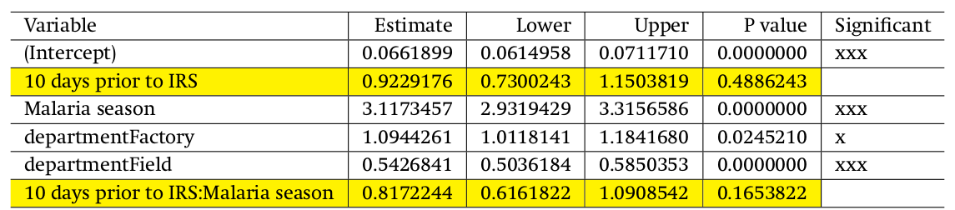

The second concern is that our quantification of return on investment is distorted by the fact that we treat IRS operations as essentially linear in nature, when in reality economies of scale, in-kind purchases and other factors likely make the true cost-per-spraying convex. We address this by creating three scenarios: (1) a “start-up” scenario in which we take into account all costs incurred by starting a program from scratch, (2) a “normal” scenario in which we match the assumptions with those used in this paper (ie, account for “wear-and-tear” depreciation but not vehicle purchase, etc.) and a (3) “absorbed costs” scenario which ignores all costs which are not directly incurred by the program…. xxx…

Discussion

- Overview of findings
- How this contributes to the literature
- Implications for policy and for businesses
- Spillover effects !
- How absenteeism might be underestimating true effect, since at the margin a sick worker might go to work (ie, not be absent), but be less productive

Limitations
- No analysis yet of different worker types (agricultural vs. industrial).
- Have not yet ventured at all into side-analyses (effect on employment, tonnage, etc.).
- Sick absenteeism seems to track absenteeism poorly: lack of clarity regarding pathways.
- Large sample size, but all from same place: questionable generalizability.

Appendix

Unadjusted absenteeism by time since IRS
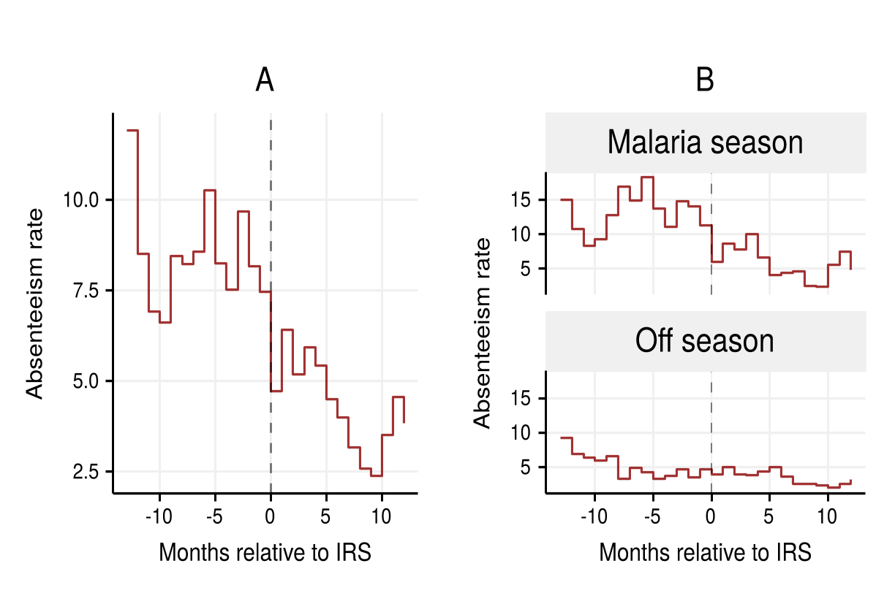
i. Absenteeism before and after IRS administration for all workers who ever received IRS; ii. The same, but segregated by malaria and non-malaria seasons

Unadjusted sick absenteeism by time since IRS
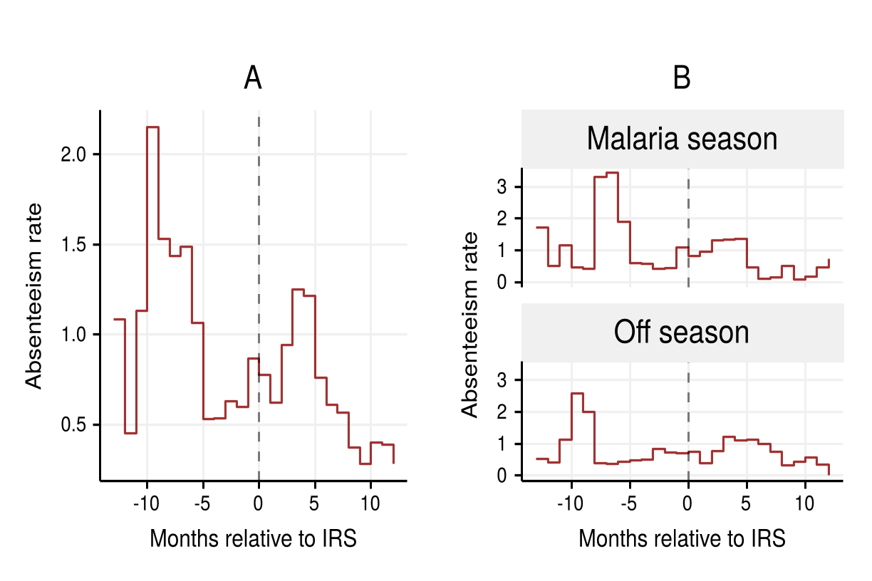
i. Sick absenteeism before and after IRS administration for all workers who ever received IRS; ii. The same, but segregated by malaria and non-malaria seasons

References
Ajani, O. I. Y., and W. M. Ashagidigbi. 2010. “Effect of Malaria on Rural Households’ Farm Income in Oyo State, Nigeria.” African Journal of Biomedical Research 11 (3). African Journals Online (AJOL). https://doi.org/10.4314/ajbr.v11i3.50723.
Alaii, Jane A., William A. Hawley, Margarette S. Kolczak, Feiko O. Ter Kuile, John E. Gimnig, John Vulule, Amos Odhacha, Aggrey J. Oloo, Bernard L. Nahlen, and Penelope A. Phillips-Howard. 2003. “Factors Affecting Use of Permethrin-Treated Bed Nets during a Randomized Controlled Trial in Western Kenya.” The American Journal of Tropical Medicine and Hygiene 68 4 Suppl: 137–41.
Alonso, Sergi, Khátia Munguambe, and Elisa Sicuri. 2017. “Market for Artemether-Lumefantrine to Treat Childhood Malaria in a District of Southern Mozambique.” Health Economics 26 (12): e345–60. https://doi.org/10.1002/hec.3514.
Asenso-Okyere, W. K., and Janet A. Dzator. 1997. “Household Cost of Seeking Malaria Care. A Retrospective Study of Two Districts in Ghana.” Social Science & Medicine 45 (5). Elsevier BV: 659–67. https://doi.org/10.1016/s0277-9536(96)00383-8.
Ashley, Elizabeth A., Aung Pyae Phyo, and Charles J. Woodrow. 2018. “Malaria.” The Lancet 391 (10130): 1608–21. https://doi.org/10.1016/S0140-6736(18)30324-6.
Asquino, Mark. 2016. “Equatorial Guinea Plays a Leading Role in Combating Malaria.” https://s3.amazonaws.com/caa-production/attachments/526/C_Pages22to27_Asquino.pdf?1446064494.
Azemar, C., and R. Desbordes. 2009. “Public Governance, Health and Foreign Direct Investment in Sub-Saharan Africa.” Journal of African Economies 18 (4). Oxford University Press (OUP): 667–709. https://doi.org/10.1093/jae/ejn028.
Bell, Andrew, and Kelvyn Jones. 2014. “Explaining Fixed Effects: Random Effects Modeling of Time-Series Cross-Sectional and Panel Data.” Political Science Research and Methods 3 (01). Cambridge University Press (CUP): 133–53. https://doi.org/10.1017/psrm.2014.7.
Binka, F. N., A. Kubaje, M. Adjuik, L. A. Williams, C. Lengeler, G. H. Maude, G. E. Armah, B. Kajihara, J. H. Adiamah, and P. G. Smith. 2007. “Impact of Permethrin Impregnated Bednets on Child Mortality in Kassena-Nankana District, Ghana: A Randomized Controlled Trial.” Tropical Medicine & International Health: TM & IH 1 (2). Wiley-Blackwell: 147–54. https://doi.org/10.1111/j.1365-3156.1996.tb00020.x.
Brew, J. R. 2017. “Malaria and Sugar: An in-Depth Examination of the Effect of Malaria Control Activities on the Health and Productivity of Maragra Sugarcane Factory Workers.” GitHub Repository. GitHub. https://github.com/joebrew/maragra.
Burton, Wayne N., Daniel J. Conti, Chin-Yu Chen, Alyssa B. Schultz, and Dee W. Edington. 1999. “The Role of Health Risk Factors and Disease on Worker Productivity.” Journal of Occupational & Environmental Medicine 41 (10). Ovid Technologies (Wolters Kluwer Health): 863–77. https://doi.org/10.1097/00043764-199910000-00007.
Buur, Lars, Carlota Mondlane Tembe, and Obede Baloi. 2012. “The White Gold: The Role of Government and State in Rehabilitating the Sugar Industry in Mozambique.” The Journal of Development Studies 48 (3). Informa UK Limited: 349–62. https://doi.org/10.1080/00220388.2011.635200.
Castel-Branco, Carlos Nuno. 2014. “Growth, Capital Accumulation and Economic Porosity in Mozambique: Social Losses, Private Gains.” Review of African Political Economy 41 (sup1): S26–48. https://doi.org/10.1080/03056244.2014.976363.
Ccm. 2016. “AngloGold Ashanti Malaria Control Ltd (AGA Mal).” Country Coordinating Mechanism of the Global Fund to Fight AIDS, Tuberculosis and Malaria. http://www.ccmghana.net/index.php/2015-2017/malaria/anglogold-ashanti.
Cohen, Jessica, and Pascaline Dupas. 2010. “Free Distribution or Cost-Sharing? Evidence from a Randomized Malaria Prevention Experiment\ast.” The Quarterly Journal of Economics 125 (1). Oxford University Press (OUP): 1–45. https://doi.org/10.1162/qjec.2010.125.1.1.
Cole, Matthew A., and Eric Neumayer. 2006. “The Impact of Poor Health on Total Factor Productivity.” The Journal of Development Studies 42 (6). Informa UK Limited: 918–38. https://doi.org/10.1080/00220380600774681.
Curtis, Christopher, Caroline Maxwell, Martha Lemnge, W. L. Kilama, Richard W. Steketee, William A. Hawley, Yves Bergevin, et al. 2003. “Scaling-up Coverage with Insecticide-Treated Nets against Malaria in Africa: Who Should Pay?” The Lancet Infectious Diseases 3 (5). Elsevier BV: 304–7. https://doi.org/10.1016/s1473-3099(03)00612-1.
Dillon, Andrew, Jed Friedman, and Pieter Serneels. 2014. Health Information, Treatment, and Worker Productivity: Experimental Evidence from Malaria Testing and Treatment among Nigerian Sugarcane Cutters. The World Bank. https://doi.org/10.1596/1813-9450-7120.
Dusfour, Isabelle, Nicole L. Achee, Ireneo Briceno, Russell King, and John P. Grieco. 2009. “Comparative Data on the Insecticide Resistance of Anopheles Albimanus in Relation to Agricultural Practices in Northern Belize, CA.” Journal of Pest Science 83 (1). Springer Nature: 41–46. https://doi.org/10.1007/s10340-009-0268-7.
Egedeye, Lorinda, Stephanie Drozer, and Anne-Marie Leiser. 2011. “Corporate Action on Malaria Control: Best Practices and Interventions.” Corporate Alliance on Malaria in Africa. http://gbchealth.org/wp-content/uploads/2014/03/CAMA-Best-Practices-Interventions.pdf.
Fink, Günther, and Felix Masiye. 2015. “Health and Agricultural Productivity: Evidence from Zambia.” Journal of Health Economics 42 (July). Elsevier BV: 151–64. https://doi.org/10.1016/j.jhealeco.2015.04.004.
García-Basteiro, Alberto L., Rafaela Miranda Ribeiro, Joe Brew, Charfudin Sacoor, Salomé Valencia, Helder Bulo, Frank Cobelens, and Eusebio Macete. 2017. “Tuberculosis on the Rise in Southern Mozambique (1997\textendash2012).” The European Respiratory Journal: Official Journal of the European Society for Clinical Respiratory Physiology 49 (3). European Respiratory Society (ERS): 1601683. https://doi.org/10.1183/13993003.01683-2016.
German, Laura, George Schoneveld, and Esther Mwangi. 2013. “Contemporary Processes of Large-Scale Land Acquisition in Sub-Saharan Africa: Legal Deficiency or Elite Capture of the Rule of Law?” World Development 48 (August). Elsevier BV: 1–18. https://doi.org/10.1016/j.worlddev.2013.03.006.
González, R., K. Munguambe, J. J. Aponte, C. Bavo, D. Nhalungo, E. Macete, P. L. Alonso, C. Menéndez, and D. Naniche. 2012. “High HIV Prevalence in a Southern Semi-Rural Area of Mozambique: A Community-Based Survey.” HIV Medicine 13 (10). Wiley-Blackwell: 581–88. https://doi.org/10.1111/j.1468-1293.2012.01018.x.
Goodman, C. A., P. G. Coleman, and A. J. Mills. 1999. “Cost-Effectiveness of Malaria Control in Sub-Saharan Africa.” The Lancet 354 (9176): 378–85. https://doi.org/10.1016/S0140-6736(99)02141-8.
Han, Lily. 2015. “Malaria in Mozambique: Trialling Payment by Results.” The Guardian. http://www.theguardian.com/global-development-professionals-network/2014/mar/31/malaria-control-payment-by-results.
Hanson, Kara. 2004. “Public and Private Roles in Malaria Control: The Contributions of Economic Analysis.” The American Journal of Tropical Medicine and Hygiene 71 (2 Suppl): 168–73. https://www.ncbi.nlm.nih.gov/pubmed/15331834.
Hong, Sok Chul. 2011. “Malaria and Economic Productivity: A Longitudinal Analysis of the American Case.” The Journal of Economic History 71 (03). Cambridge University Press (CUP): 654–71. https://doi.org/10.1017/s0022050711001872.
Howard, Natasha, Lorna Guinness, Mark Rowland, Naeem Durrani, and Kristian S. Hansen. 2017. “Cost-Effectiveness of Adding Indoor Residual Spraying to Case Management in Afghan Refugee Settlements in Northwest Pakistan during a Prolonged Malaria Epidemic.” PLoS Neglected Tropical Diseases 11 (10): e0005935. https://doi.org/10.1371/journal.pntd.0005935.
Ijumba, J. N., F. W. Mosha, and S. W. Lindsay. 2002. “Malaria Transmission Risk Variations Derived from Different Agricultural Practices in an Irrigated Area of Northern Tanzania.” Medical and Veterinary Entomology 16 (1). Wiley-Blackwell: 28–38. https://doi.org/10.1046/j.0269-283x.2002.00337.x.
INE. 2011. “Demographic Health Survey.” Instituto Nacional de Estatistica. http://www.ine.gov.mz/.
Jaleta, Kassahun T., Sharon R. Hill, Emiru Seyoum, Meshesha Balkew, Teshome Gebre-Michael, Rickard Ignell, and Habte Tekie. 2013. “Agro-Ecosystems Impact Malaria Prevalence: Large-Scale Irrigation Drives Vector Population in Western Ethiopia.” Malaria Journal 12 (1). Springer Nature: 350. https://doi.org/10.1186/1475-2875-12-350.
Kaula, Henry, Peter Buyungo, and Jimmy Opigo. 2017. “Private Sector Role, Readiness and Performance for Malaria Case Management in Uganda, 2015.” Malaria Journal 16 (1). Springer Nature. https://doi.org/10.1186/s12936-017-1824-x.
Liu, Lei, Robert L. Strawderman, Mark E. Cowen, and Ya-Chen T. Shih. 2010. “A Flexible Two-Part Random Effects Model for Correlated Medical Costs.” Journal of Health Economics 29 (1). Elsevier BV: 110–23. https://doi.org/10.1016/j.jhealeco.2009.11.010.
Mayor, Alfredo, John J. Aponte, Carole Fogg, Francisco Saúte, Brian Greenwood, Martinho Dgedge, Clara Menendez, and Pedro L. Alonso. 2007. Malaria Journal 6 (1). Springer Nature: 3. https://doi.org/10.1186/1475-2875-6-3.
McCarthy, Desmond, Holger Wolf, and Yi Wu. 2000. “The Growth Costs of Malaria.” Cambridge, MA: National Bureau of Economic Research. https://doi.org/10.3386/w7541.
Minalu, G., M. Aerts, S. Coenen, A. Versporten, A. Muller, N. Adriaenssens, P. Beutels, G. Molenberghs, H. Goossens, and N. Hens. 2011. “Application of Mixed-Effects Models to Study the Country-Specific Outpatient Antibiotic Use in Europe: A Tutorial on Longitudinal Data Analysis.” The Journal of Antimicrobial Chemotherapy 66 (suppl 6). Oxford University Press (OUP): vi79–87. https://doi.org/10.1093/jac/dkr460.
Mocumbi, Sibone, Mitzy Gafos, Khatia Munguambe, Ruth Goodall, and Sheena McCormack. 2017. “High HIV Prevalence and Incidence among Women in Southern Mozambique: Evidence from the MDP Microbicide Feasibility Study.” Edited by Hajo Zeeb. PloS One 12 (3). Public Library of Science (PLoS): e0173243. https://doi.org/10.1371/journal.pone.0173243.
Moonasar, Devanand, Rajendra Maharaj, Simon Kunene, Baltazar Candrinho, Francisco Saute, Nyasatu Ntshalintshali, and Natashia Morris. 2016. “Towards Malaria Elimination in the MOSASWA (Mozambique, South Africa and Swaziland) Region.” Malaria Journal 15 (1): 419. https://doi.org/10.1186/s12936-016-1470-8.
Mouzin, Eric, and Et Al. 2011. “Business Investing in Malaria Control: Economic Returns and a Healthy Workforce for Africa.” Progress \&\} Impact Series, no. 6.
Nhacolo, Ariel Q., Delino A. Nhalungo, Charfudin N. Sacoor, John J. Aponte, Ricardo Thompson, and Pedro Alonso. 2006. “Levels and Trends of Demographic Indices in Southern Rural Mozambique: Evidence from Demographic Surveillance in Manhiça District.” BMC Public Health 6 (1). Springer Nature. https://doi.org/10.1186/1471-2458-6-291.
Nonvignon, Justice, Genevieve Cecilia Aryeetey, Keziah L. Malm, Samuel Agyei Agyemang, Vivian N. A. Aubyn, Nana Yaw Peprah, Constance N. Bart-Plange, and Moses Aikins. 2016. “Economic Burden of Malaria on Businesses in Ghana: A Case for Private Sector Investment in Malaria Control.” Malaria Journal 15 (September): 454. https://doi.org/10.1186/s12936-016-1506-0.
O’Laughlin, Bridget. 2016. “Consuming Bodies: Health and Work in the Cane Fields in Xinavane, Mozambique.” Journal of Southern African Studies 43 (3). Informa UK Limited: 625–41. https://doi.org/10.1080/03057070.2016.1190519.
Orem, Juliet Nabyonga, Joses Muthuri Kirigia, Robert Azairwe, Ibrahim Kasirye, and Oladapo Walker. 2012. “Impact of Malaria Morbidity on Gross Domestic Product in Uganda.” International Archives of Medicine 5 (1): 12. https://doi.org/10.1186/1755-7682-5-12.
Overgaard, Hans J., Vamsi P. Reddy, Simon Abaga, Abrahan Matias, Michael R. Reddy, Vani Kulkarni, Christopher Schwabe, Luis Segura, Immo Kleinschmidt, and Michel A. Slotman. 2012. “Malaria Transmission after Five Years of Vector Control on Bioko Island, Equatorial Guinea.” Parasites & Vectors 5 (1). Springer Nature: 253. https://doi.org/10.1186/1756-3305-5-253.
Phillips, S. Foster M. 1998. “Economics and Its Contribution to the Fight against Malaria.” Annals of Tropical Medicine and Parasitology 92 (4). Informa UK Limited: 391–98. https://doi.org/10.1080/00034989859375.
Pluess, Bianca, Ivo Mueller, Damien Levi, Graham King, Thomas A. Smith, and Christian Lengeler. 2009. “Malaria \textendash a Major Health Problem within an Oil Palm Plantation around Popondetta, Papua New Guinea.” Malaria Journal 8 (1). Springer Nature: 56. https://doi.org/10.1186/1475-2875-8-56.
Purdy, Mark, Matthew Robinson, Kuangyi Wei, and David Rublin. 2013. “The Economic Case for Combating Malaria.” The American Journal of Tropical Medicine and Hygiene 89 (5): 819–23. https://doi.org/10.4269/ajtmh.12-0689.
Robbins, Glen, and David Perkins. 2012. “MINING FDI AND INFRASTRUCTURE DEVELOPMENT ON AFRICA’S EAST COAST: EXAMINING THE RECENT EXPERIENCE OF TANZANIA AND MOZAMBIQUE: Mining FDI and Infrastructure Development.” Journal of International Development 24 (2): 220–36. https://doi.org/10.1002/jid.2817.
Sachs, Jeffrey, and Pia Malaney. 2002. “The Economic and Social Burden of Malaria.” Nature 415 (6872): 680–85. https://doi.org/10.1038/415680a.
Sacoor, C., A. Nhacolo, D. Nhalungo, J. J. Aponte, Q. Bassat, O. Augusto, I. Mandomando, et al. 2013. “Profile: Manhica Health Research Centre (Manhica HDSS).” International Journal of Epidemiology 42 (5). Oxford University Press (OUP): 1309–18. https://doi.org/10.1093/ije/dyt148.
Saúte, Francisco, John Aponte, Jesus Ahmeda, Carlos Ascaso, Neide Vaz, Martinho Dgedge, and Pedro Alonso. 2003. “Malaria in Southern Mozambique: Incidence of Clinical Malaria in Children Living in a Rural Community in Manhiça District.” Transactions of the Royal Society of Tropical Medicine and Hygiene 97 (6). Oxford University Press (OUP): 655–60. https://doi.org/10.1016/s0035-9203(03)80097-4.
Shretta, Rima, Anton L. V. Avanceña, and Arian Hatefi. 2016. “The Economics of Malaria Control and Elimination: A Systematic Review.” Malaria Journal 15 (1): 593. https://doi.org/10.1186/s12936-016-1635-5.
Shretta, Rima, Ranju Baral, Anton L. V. Avanceña, Katie Fox, Asoka Premasiri Dannoruwa, Ravindra Jayanetti, Arumainayagam Jeyakumaran, Rasike Hasantha, Lalanthika Peris, and Risintha Premaratne. 2017. “An Investment Case to Prevent the Reintroduction of Malaria in Sri Lanka.” The American Journal of Tropical Medicine and Hygiene, January. American Society of Tropical Medicine and Hygiene, 16–0209. https://doi.org/10.4269/ajtmh.16-0209.
The Lancet. 2011. “Malaria: Control vs Elimination vs Eradication.” The Lancet 378 (9797): 1117. https://doi.org/10.1016/S0140-6736(11)61489-X.
Vecchi, Veronica, Mark Hellowell, and Stefano Gatti. 2013. “Does the Private Sector Receive an Excessive Return from Investments in Health Care Infrastructure Projects? Evidence from the UK.” Health Policy 110 (2-3): 243–70. https://doi.org/10.1016/j.healthpol.2012.12.010.
White, Michael T., Lesong Conteh, Richard Cibulskis, and Azra C. Ghani. 2011. “Costs and Cost-Effectiveness of Malaria Control Interventions--a Systematic Review.” Malaria Journal 10 (November): 337. https://doi.org/10.1186/1475-2875-10-337.
White, Nicholas J., Sasithon Pukrittayakamee, Tran Tinh Hien, M. Abul Faiz, Olugbenga A. Mokuolu, and Arjen M. Dondorp. 2014. “Malaria.” The Lancet 383 (9918): 723–35. https://doi.org/10.1016/S0140-6736(13)60024-0.
WHO. 2015. “Malaria Profile: Mozambique.” World Health Organization. http://www.who.int/malaria/publications/country-profiles/profile_moz_en.pdf.
Winkler, Deborah. 2013. “Potential and Actual FDI Spillovers in Global Value Chains.” Policy Research Working Paper.
Wondwosen, Betelehem, Göran Birgersson, Habte Tekie, Baldwyn Torto, Rickard Ignell, and Sharon R. Hill. 2018. “Sweet Attraction: Sugarcane Pollen-Associated Volatiles Attract Gravid Anopheles Arabiensis.” Malaria Journal 17 (1). Springer Nature. https://doi.org/10.1186/s12936-018-2245-1.
World Health Organization. 2016. World Malaria Report 2015. World Health Organization. https://books.google.com/books/about/World_Malaria_Report_2015.html?hl=&id=rg4LDgAAQBAJ.

